University of Central Missouri

Department of Computer Science & Cybersecurity

CS5720 Neural network and Deep learning

Fall 2026

Home Assignment 4.

Student name: Ruyi Gai

Submission Requirements:
- Total Points: 100
- Once finished your assignment push your source code to your repo (GitHub) and explain the work through the ReadMe file properly. Make sure you add your student info in the ReadMe file.
- Submit your GitHub link on the Bright Space.
- Comment your code appropriately IMPORTANT.
- Any submission after provided deadline is considered as a late submission.

Part I. Short answer
Question 1. Sequence-to-Sequence Models and Attention
(a) Explain the purpose of the encoder and decoder in a sequence-to-sequence (Seq2Seq) model for machine translation.
In a sequence-to-sequence model for machine translation, the encoder reads the source sentence and converts it into a vector representation. The decoder uses the encoded source information and the previously generated target tokens to predict the next target token, one at a time, until it produces an end-of-sequence token.

(b) Why does a traditional encoder-decoder model that relies on a fixed-length context vector often perform poorly when translating long sentences?
A traditional encoder–decoder model compresses the entire source sentence into a single fixed-length context vector. As the sentence gets longer, this vector must capture more information without increasing in size. This creates an information bottleneck. If important details are lost during encoding, the decoder has less information available to produce an accurate translation.

(c) Explain how the attention mechanism helps address this limitation. What information can the decoder access through attention?
Attention allows the decoder to access the encoder hidden states for all positions in the source sentence at each decoding step. The decoder scores these states using its decoding state, applies softmax to obtain attention weights, and computes a weighted sum of the encoder states. This produces a step-specific context vector. The decoder can therefore focus on different parts of the source sentence as it generates different target tokens, reducing the fixed-length bottleneck.

Question 2. Attention Mechanisms
(a) Explain the difference between hard attention and soft attention. Why is soft attention generally easier to train using backpropagation?
Hard attention makes a discrete choice at each decoding step and uses the information from the selected input position. Soft attention assigns a weight to each input position and computes a weighted sum of the encoder hidden states.
Soft attention is generally easier to train with backpropagation because softmax and the weighted sum are differentiable, allowing gradients to flow back to the parameters that compute the attention scores. A discrete selection in hard attention does not generally support ordinary backpropagation directly.

(b) Consider the following decoder state and three encoder hidden states. Using dot-product attention, calculate the attention score for each encoder hidden state, eᵢ = sᵀhᵢ.
s = [1, 0] h₁ = [1, 0] h₂ = [0, 1] h₃ = [1, 1]
e1=[1,0][1,0]=1 e2=[1,0][0,1]=0 e3=[1,0][1,1]=1 et=[1,0,1]
(c) Apply the softmax function to the three attention scores to obtain the attention weights. Then calculate the context vector as the weighted sum of the encoder hidden states. Round your results to three decimal places.
Attention weights:
a1= exp(1)/[exp(1)+exp(0)+exp(1)]=0.422
a2= exp(0)/[exp(1)+exp(0)+exp(1)]=0.155
a3= exp(1)/[exp(1)+exp(0)+exp(1)]=0.422
Context vector:
c1= h1×a1=0.422×[1,0]=[0.422,0]
c2= h2×a2=0.155×[0,1]=[0,0.155]
c3= h3×a3=0.422×[1,1]=[0.422,0.422]
ct=[0.422+0+0.422,0+0.155+0.422]=[0.844,0.577]

Question 3. Self-Attention in Transformers
(a) What is self-attention? Explain how it differs from the encoder-decoder attention mechanism used in traditional Seq2Seq models.
Self-attention is an attention mechanism where the queries, keys, and values all come from the same sequence, so each token combines information from other positions in that sequence.
Encoder–decoder attention differs because its query comes from the decoder, while its keys and values come from the encoder’s source representations. Therefore, self-attention operates within one sequence, whereas encoder–decoder attention connects the target sequence with the source sequence.

(b) Describe the roles of the Query (Q), Key (K), and Value (V) vectors in self-attention.
A Query represents what the current token is looking for.
A Key is compared with the query to determine how relevant a position is.
A Value contains the information that position contributes to the output.
The model computes attention scores from queries and keys, applies softmax to obtain attention weights, and uses those weights to sum the value vectors.

(c) Explain how self-attention allows a Transformer to capture relationships between words that are far apart in a sentence. Provide one example.
Self-attention allows a token to attend directly to another visible token in the same layer, even when many words occur between them. For example, in “The book that I borrowed from the library last week was fascinating,” the token was can attend directly to book, helping the model capture that book is the subject of was.

Question 4. Multi-Head Attention
(a) What is multi-head attention, and why does a Transformer use multiple attention heads instead of a single attention head?
Multi-head attention runs several attention heads in parallel on the same input. Each head uses its own learned projections to form queries, keys, and values, and computes attention independently. A single head produces one set of attention weights per query, while multiple heads allow the model to learn different attention patterns and capture different relationships at the same time.

(b) Suppose a Transformer uses an embedding dimension of 512 and 8 attention heads. Assuming the dimensions are divided equally among the heads, calculate the dimension of each attention head. Show your calculation.
The dimension of each attention head is 512/8=64.

(c) After each attention head generates its output, how are the outputs combined to produce the final multi-head attention representation?
The outputs of the attention heads are concatenated along the feature dimension. The concatenated result is then passed through a learned linear output projection Wo to produce the final multi-head attention representation.

Question 5. Transformer Architecture
(a) Why do Transformers need positional encodings? Explain what information positional encodings provide to the model.
Self-attention by itself does not encode token order. Positional encodings give the model information about where tokens occur in the sequence, helping it distinguish their order and infer how far apart they are. In the original Transformer, positional encodings are added to the token embeddings.

(b) What is masked self-attention in a Transformer decoder? Why must the decoder prevent a token from attending to future tokens during autoregressive training?
Masked self-attention uses a causal mask so that each decoder position can attend only to itself and earlier input positions. During autoregressive training, the target sequence is available in advance. The mask prevents the model from seeing the token it is supposed to predict or any later tokens, so it learns to predict the next token using only the available prefix.

(c) Compare RNNs and Transformers in terms of sequential processing and parallel computation. Explain one important advantage of Transformers and one limitation during autoregressive text generation.
An RNN processes a sequence step by step because each hidden state depends on the previous hidden state. A Transformer removes this recurrent dependency, allowing it to compute representations for multiple token positions in parallel within a layer during training.
This makes better use of parallel hardware and can improve training efficiency. However, autoregressive generation still proceeds one token at a time because each new prediction depends on the tokens already generated.

Part II. Programming
Q1: NLP Preprocessing Pipeline
Write a Python function that performs basic NLP preprocessing on a sentence. The function should do the following steps:
- Tokenize the sentence into individual words.
- Remove common English stopwords (e.g., "the", "in", "are").
- Apply stemming to reduce each word to its root form.
Use the sentence:
"NLP techniques are used in virtual assistants like Alexa and Siri."
The function should print:
- A list of all tokens
- The list after stop words are removed
- The final list after stemming
Expected Output:
Your program should print three outputs in order:
- Original Tokens – All words and punctuation split from the sentence
- Tokens Without Stopwords – Only meaningful words remain
- Stemmed Words – Each word is reduced to its base/root form

Short Answer Questions:
- What is the difference between stemming and lemmatization? Provide examples with the word “running.”
Stemming crudely strips affixes to a stem, which may not be a valid word; lemmatization uses vocabulary and morphological analysis to return the dictionary base form (lemma). For “running,” stemming often gives “run” (or “runn” depending on the stemmer), while lemmatization gives “run” when it is a verb, and may keep “running” when it is a noun.

- Why might removing stop words be useful in some NLP tasks, and when might it actually be harmful?
Removing stop words can be useful in tasks such as keyword search and word-frequency analysis. Common words like “the” and “of” often contribute little to identifying the topic, so removing them reduces the number of features and helps the system focus on more informative words.
However, removing stop words can be harmful when the task depends on grammar, context, or negation. For example, in sentiment analysis, removing “not” from “not good” leaves “good,” which may cause a negative phrase to be classified as positive.

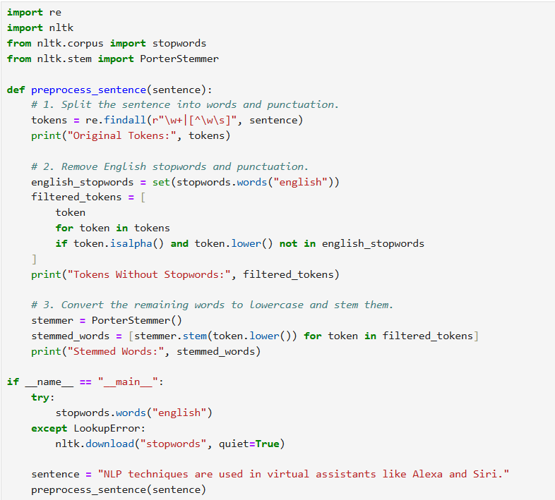

Q2: Named Entity Recognition with SpaCy

Task: Use the spaCy library to extract named entities from a sentence. For each entity, print:
- The entity text (e.g., "LeBron James")
- The entity label (e.g., PERSON, DATE)
- The start and end character positions in the string
Use the input sentence:
" LeBron James as the NBA player of the United States in Laker and won the NBA Final MVP in 2020."
Expected Output:
Each line of the output should describe one entity detected
Short Answer Questions:
- How does NER differ from POS tagging in NLP?
Named entity recognition (NER) identifies spans of text that refer to people, organizations, locations, dates, and other entities, and assigns a category to each span.
Part-of-speech (POS) tagging assigns a grammatical category to each token, such as noun, verb, or adjective.
- Describe two applications that use NER in the real world (e.g., financial news, search engines).
Resume Screening: NER can extract company names, universities, and employment dates from resumes. A recruiting system can use this information to fill in structured fields, making it easier for recruiters to review candidates’ education and work history.
Customer Support: NER can extract product names and dates from customer messages. For example, in “My Galaxy S24 stopped charging on Monday,” it can identify “Galaxy S24” as a product and “Monday” as a date. The support system can use the product name to route the request to the appropriate team.

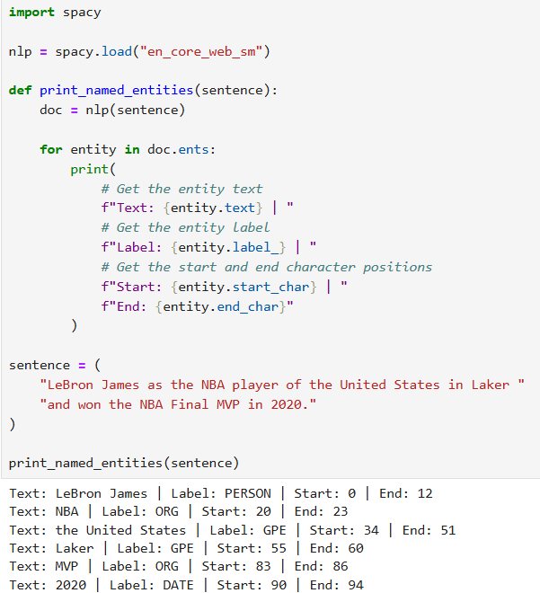
Q3: Scaled Dot-Product Attention

Task: Implement the scaled dot-product attention mechanism. Given matrices Q (Query), K (Key), and V (Value), your function should:
- Compute the dot product of Q and Kᵀ
- Scale the result by dividing it by √d (where d is the key dimension)
- Apply softmax to get attention weights
- Multiply the weights by V to get the output
Use the following test inputs:
Q = np.array([[1, 0, 1, 0], [0, 1, 0, 1]])
K = np.array([[1, 0, 1, 0], [0, 1, 0, 1]])
V = np.array([[1, 2, 3, 4], [5, 6, 7, 8]])

Expected Output Description:
Your output should display:
- The attention weights matrix (after softmax)
- The final output matrix
Short Answer Questions:
- Why do we divide the attention score by √d in the scaled dot-product attention formula?
Assuming the query and key components are mutually independent with zero mean and unit variance, their dot product has variance d, where d is the key dimension. Dividing the dot product by √d gives it unit variance under these assumptions. This keeps the scores from growing too large as d increases, reducing softmax saturation and helping prevent very small gradients during training.

- How does self-attention help the model understand relationships between words in a sentence?
Self-attention lets each token build a context-aware representation by gathering information from relevant positions in the same sentence. It compares the token’s query with the keys of visible tokens and uses the resulting attention weights to compute a weighted sum of their value vectors. For example, in “She sat on the bank of the river,” bank can attend to river, which helps the model interpret bank as the side of a river.



